Chapter 6, Solution 66.

If v=i, then
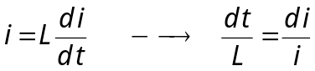
Integrating this gives
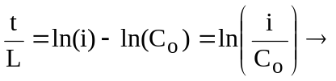 i = C_{o}e^{t/L}
i(0) = 2 = C_{o}

i(t) = 2e^{t/0.02} = 2e^{50t} A.

